**Form Layouts and Screenshots**

**1. Login Form**

**2. Password Change Form**

**3. View Entries Form**

**4. Log Fault Form**

**5. Administrator Form**

**6. Edit Rooms Form**

**7. Edit Computers Form**

**8. Edit Users Form**

**9. Technician Form**

**10. Inactive Faults Form**

**11. Room Faults Form**

**12. Update Status Form**

**13. Resolve Form**

**Login Form**



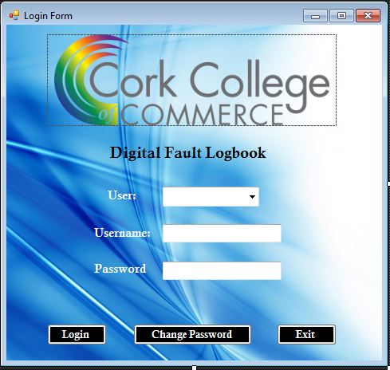

**Password Change Form**



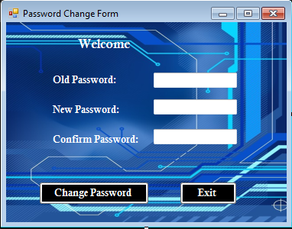

**View Entries Form**



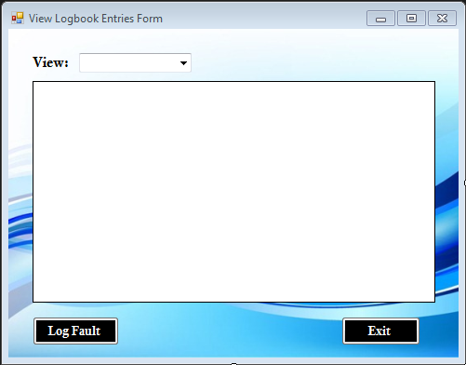

**Log Fault Form**



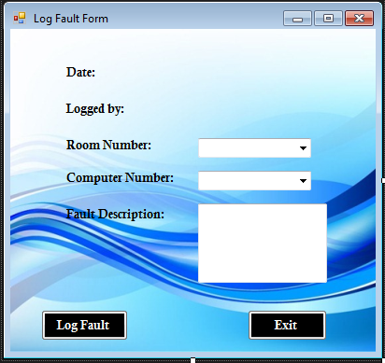

**Administrator Form**

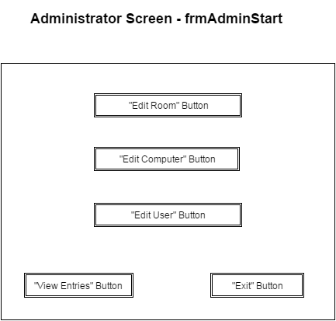

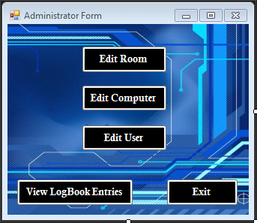

**Edit Rooms Form**

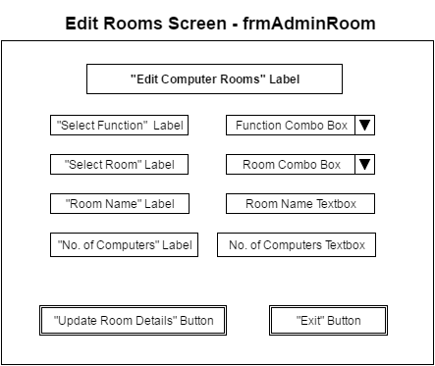

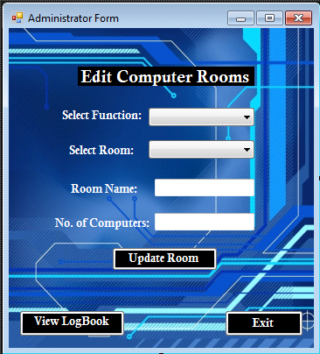

**Edit Computers Form**

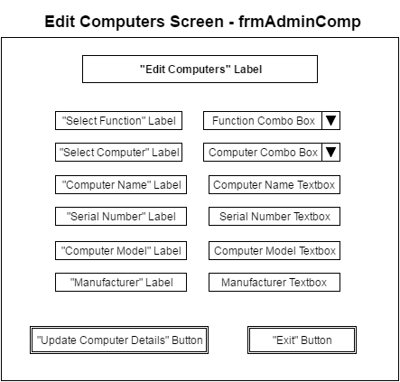

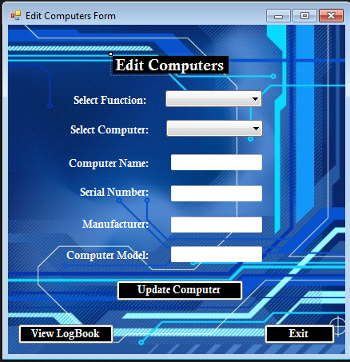

**Edit Users Form**

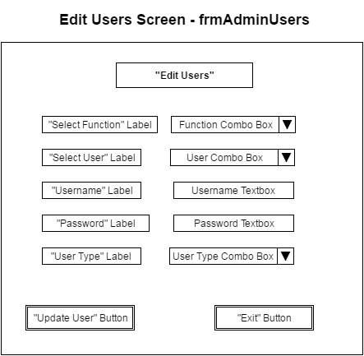

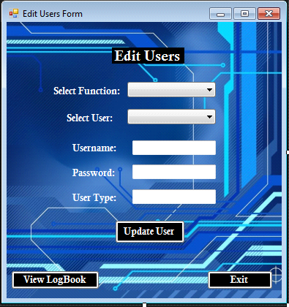

**Technician Form**



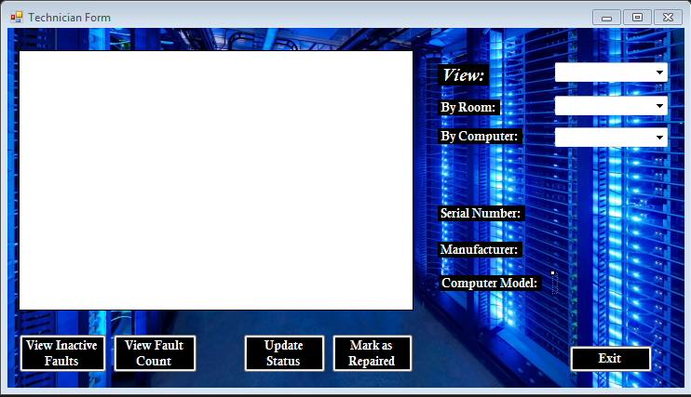

**Inactive Faults Form**



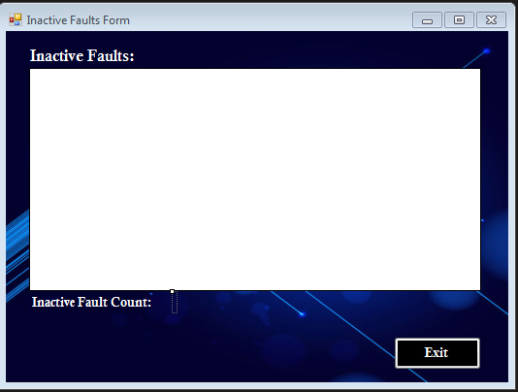

**Room Faults Form**



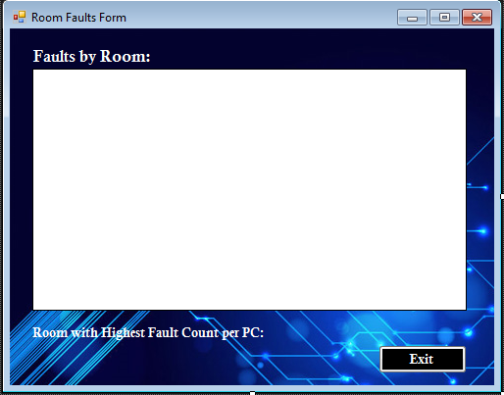

**Update Status Form**



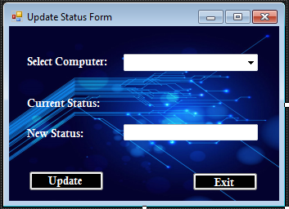

**Resolve Form**



